**Ampli Biochemistry Kit: Advanced Level**

**Today we will be experimenting with several things:**

* Designing Ampli circuits for modular flow chemistry
* Constructing a linear chemical reaction with various elements to create nylon polymers
* Characterizing the yeast->ethanol bioreactor and production efficiency
* Utilizing the ethanol product in organic synthesis reactions

**Materials**

Check that you have all of the following:

* Ampli bioreactor with fermenting yeast culture
* Set of Ampli blocks
* Forceps
* Plastic pipette droppers
* Hot Hands warming pad
* Food coloring
* pH strips and urinalysis strips
* Lab coat and gloves
* Your teacher will supply methanol and ethanol if needed
* Your classroom will have color sensors, SensorTags, and multimeters to share

**Safety**

In our activities today we will be working with real chemical reagents, the same as those used in organic chemistry labs. Some may be flammable, corrosive, or toxic when in concentrated form. Our chemicals are inside the blocks, so do not require the protective equipment used in a traditional laboratory setting, but they should be handled with care. When doing the Nylon Synthesis and Ampli Organic Chemistry activities, don’t take apart any blocks (and ask a teacher for help if they come apart by accident), don’t connect chemical blocks in ways other than directed, and don’t heat any blocks unless instructed to do so. If you ever see anything unexpected, weird, or confusing with your chemical blocks, ask a teacher to evaluate it. And make sure to always be wearing your lab coat and gloves!

**1. Introduction to Ampli**

Take a look at your Ampli blocks. They each have paper for flowing fluids inside, and interlocking frames like puzzle pieces. Design a circuit with 5 blocks, and flow food coloring through it. What directions does flow occur? What pathways can you create?

Discussion Questions:

* In what ways does this system differ from traditional laboratory chemistry? How might this system be uniquely useful?

**2. Nylon Synthesis**

One of the things we can do with Ampli blocks is chemistry! Your teacher will tell you about polymers and how to create them. A common polymer you might find in your clothing, shoes, toothbrushes, guitar strings, and more is nylon. We can make it today!

Connect your nylon reaction blocks together on your red Ampli board like this:

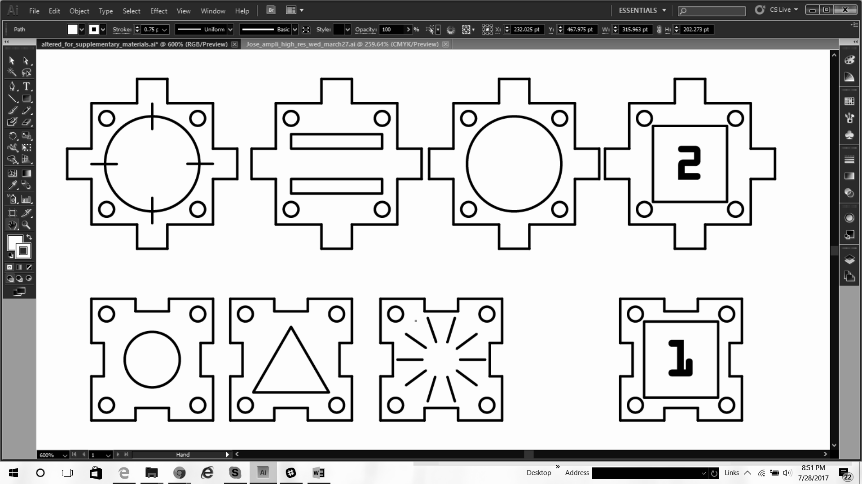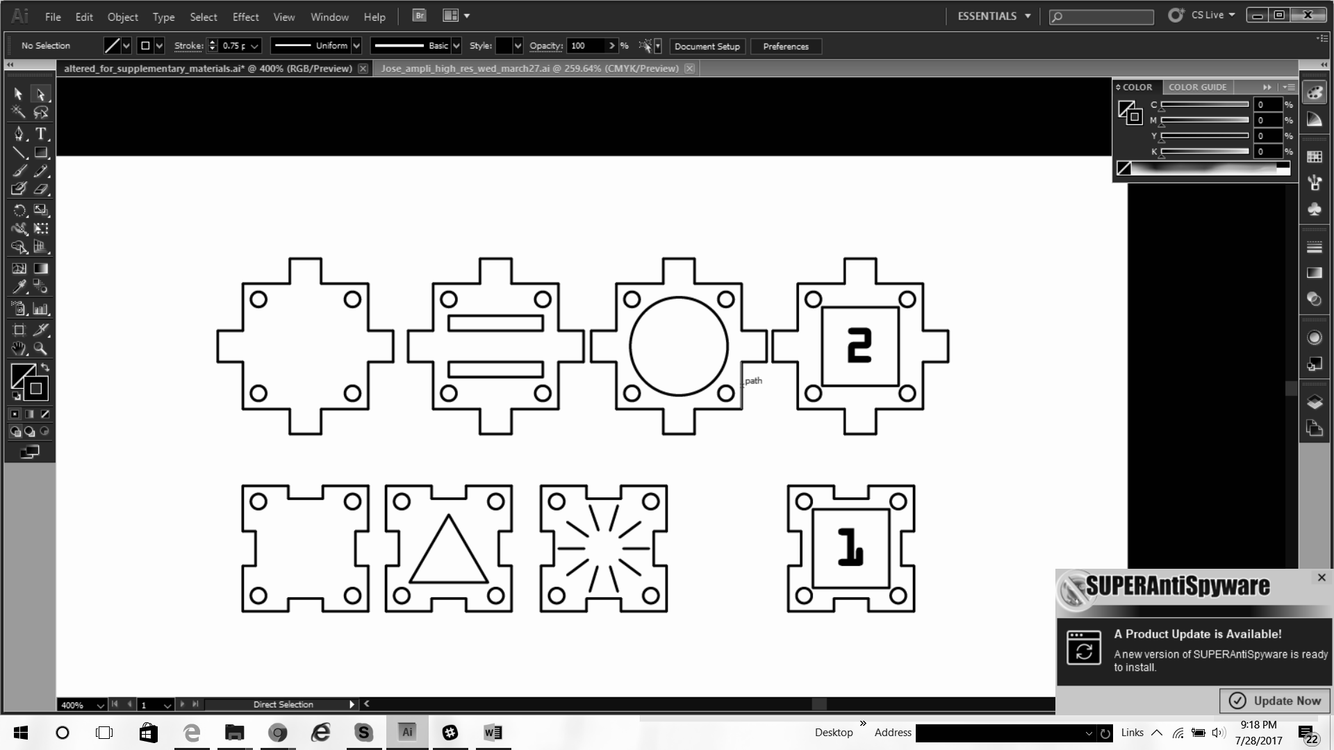

**Don’t forget to wear gloves and a lab coat!**

When you are certain that the blocks are assembled correctly, ask your teacher for some methanol. Pipette the methanol into the open pipette block a little at a time, and watch it flow through the system. When it reaches the last block, stop pipetting! Open a Hot Hands packet, shake to start the warming process, and lay it carefully over the entire chain of blocks. Leave it to incubate for at least 30 minutes -- you can come back and check on it at the end of the Ampli Organic Chemistry activity! Make sure your blocks stay wet during this time period. You may need to pipette a little more methanol into the system every 10 minutes or so.

When at least 30 minutes have passed, remove the heat pack and connect the color change blocks like this:

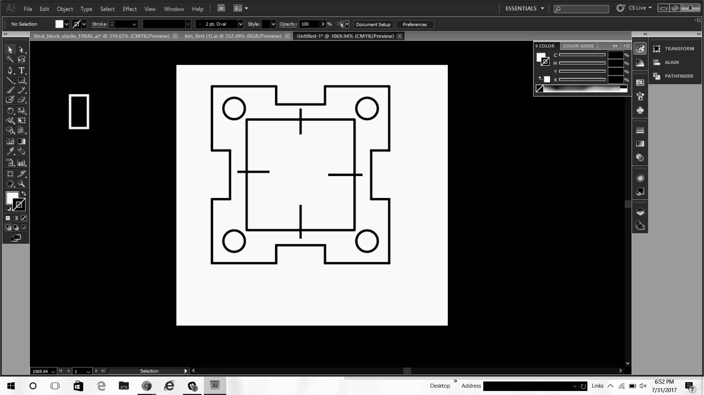

Flow some water through the system by pipetting into the pipette block, the same as you did with methanol. This will wash the nylon polymer chains into the nanoparticle block, where they will bind with gold nanoparticles. Keep a close eye on the last block of the system -- as the nylon flows into it, you should see a slight yellow color. This is the gold nylon you just made!

Discussion questions:

* What other kinds of things are polymers? What would be a useful polymer to make with an Ampli kit?
* Can you see the nylon fibers? Why do you think you can or can’t?
* Can you come up with any properties of nylon polymers that you might be able to test?

**3. Ampli Organic Chemistry**

Another thing we can do with Ampli blocks is bioprocessing. Your teacher will tell you about bioreactors, ethanol production, and downstream processing. One of the most useful ways to process ethanol is to perform organic synthesis -- the process of chemically adding or removing a set of molecules from a structure in order to create an entirely new substance. In this case, we will use ethanol two ways: to form acetaldehyde and acetic acid (also known as very strong vinegar)!

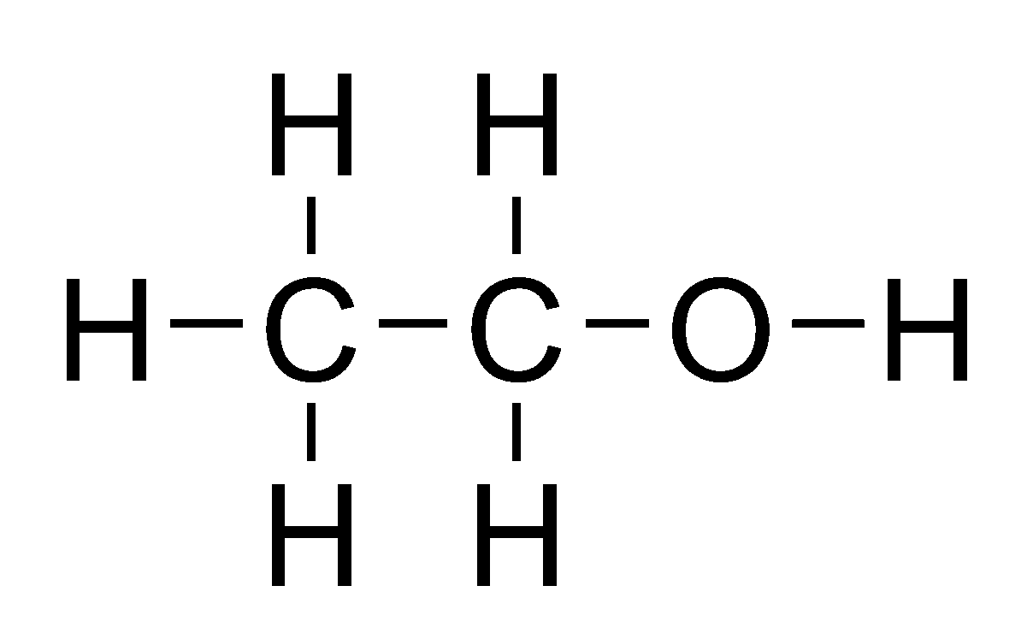 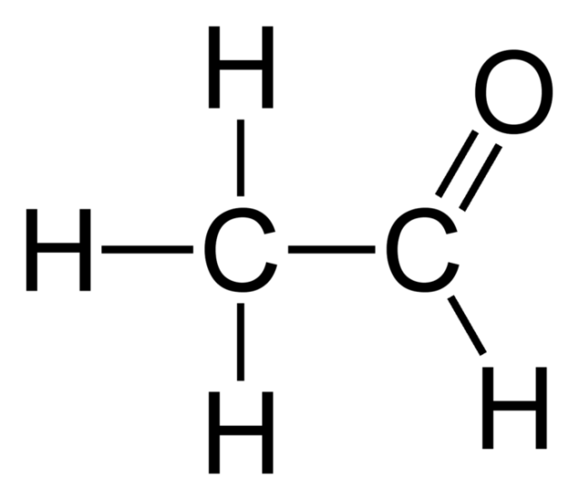 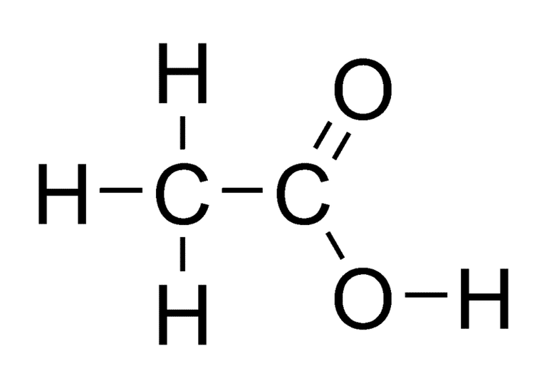

Ethanol Acetaldehyde Acetic Acid

Before we get started, check your bioreactor to see if the yeast are producing enough ethanol to be used for synthesis.

* Remove the lid of the bioreactor and use the urinalysis strips to test the sugar (glucose) content of your yeast media. Compare to your teacher’s bioreactor. Since yours is undergoing fermentation, it should have less sugar. If it doesn’t, that may be an indication that your yeast has not produced enough ethanol yet.
* Dip a metal fork, glass rod, or similar into the bioreactor, taking care to only touch the clear supernatant fluid and not the soft, yellow-white yeast. With your teacher’s supervision, pass the fork through the top of a flame. You should see the ethanol burning off the fork! If you don’t see flames on the fork, this may be an indication that your yeast has not produced enough ethanol yet.

If you think your bioreactor may not have much ethanol content, get some pure ethanol from your teacher and pour a few mL into the bioreactor to use instead.

When you have verified that your bioreactor contains ethanol, set up your chemical blocks like this and lastly, connect them to the bioreactor with a ramp!

**Don’t forget to wear gloves and a lab coat!**

Acetaldehyde:



Acetic Acid:



Give the chemicals some time to mix and flow, maybe 10-20 minutes or so. As the reactions run, there are lots of experiments you can try to monitor the progress of the reaction and verify the existence of a new chemical product.

* Watch the chemical blocks for color changes -- you may see the Potassium Permanganate block turn from dark purple to brown, and you may see the PCC block turn from orange to clear or brown. Experiment with the color sensor to see if it picks up any changes!
* Try comparing the pH block where you made acetic acid, to the pH of the bioreactor. There should be a difference! Do you predict that acetic acid will be higher or lower pH than the bioreactor?
* Use the classroom multimeters to test electrical conductivity and resistance of various blocks, particularly the block where you made acetaldehyde. Compare to the bioreactor, to your food coloring blocks, or to a drop of water on the table. What do you notice?
* What else can you test with the materials in your classroom? Be creative!

At the end of class, carefully tape a SensorTag above your bioreactor and re-wrap airtight with plastic wrap so that the yeast can continue fermentation overnight. Your teacher will show you how to turn on the SensorTag and track it online, so you can watch temperature and pressure changes as the fermentation progresses!

Discussion Questions:

* What do you know about the properties of ethanol, acetaldehyde, and acetic acid? Can you think of other properties you might be able to test with other materials?
* You are actually very familiar with acetic acid -- a very dilute version is called vinegar. What did you learn about its properties today? Does that explain anything about the taste of vinegar, or the disinfectant and odor-removal properties of vinegar?
* Was there anything that didn’t turn out as you expected? Can you think of anything (errors, protocol changes, environmental factors, and more) which might have affected this? Can you think of changes you might want to implement to make these reactions more efficient or effective?
* What did you learn today? What are you going to research or investigate more in the future?